**JQUERY ASSIGNMENT**

Q1) What is jQuery?

Ans) 1. jQuery is a JavaScript library that streamlines web development tasks. 2. It simplifies HTML document traversal and manipulation, event handling, animation, and AJAX interactions.

3. jQuery was created by John Resig in 2006 and is widely used by developers worldwide.

4. It allows for writing less code and achieving more functionality compared to traditional JavaScript.

5. jQuery offers a concise and intuitive API for common tasks like element selection, attribute manipulation, event handling, and asynchronous HTTP requests.

-> Some key features of jQuery include:

1. DOM manipulation: jQuery simplifies the process of selecting and manipulating HTML elements in the Document Object Model (DOM), allowing developers to easily add, remove, or modify elements and their attributes.

2. Event handling: jQuery provides methods for attaching event handlers to DOM elements, enabling developers to respond to user actions such as clicks, mouse movements, keyboard input, and form submissions.

3. AJAX support: jQuery includes functions for making asynchronous HTTP requests, allowing developers to fetch data from a server without reloading the entire web page. This enables the creation of interactive and dynamic web applications

4. Animation effects: jQuery offers a suite of built-in animation methods that allow developers to create visually appealing effects such as fading, sliding, and toggling elements on a web page.

5. Cross-browser compatibility: jQuery abstracts away many of the differences between web browsers, providing a consistent API that works reliably across various browsers and versions.

Q2) How to apply CSS using Jquery, how to add or remove Class in jquery, jquery animation?

-Below is the button operated task ,onclick the background color fades.

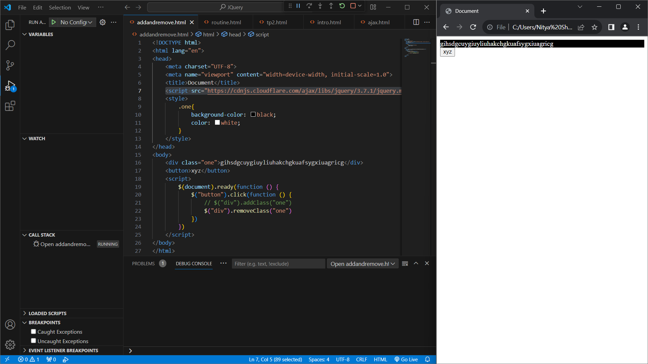

Q3) How to create slider with animation?

- Kindly check Github account.

Q4) Event bubbling tickling example ?

-Kindly check Github account.